ASSIGNMENT NO: 04

AIM: Design and implement real time monitoring system using android phone (Blynk App.) such as' soil parameter monitoring'.

Objective:
- To learn the interface of sensors and actuators using Arduino Uno/Raspeberry Pi.
- To learn and understand IoT platforms and their significance for real time applications.

Theory:
- Write discerption of soil moisture sensor.
The soil moisture sensor is one kind of sensor used to gauge the volumetric content of water within the soil. As the straight gravimetric dimension of soil moisture needs eliminating, drying, as well as sample weighting. These sensors measure the volumetric water content not directly with the help of some other rules of soil like dielectric constant, electrical resistance, otherwise interaction with neutrons, and replacement of the moisture content.
The relation among the calculated property as well as moisture of soil should be adjusted & may change based on ecological factors like temperature, type of soil, otherwise electric conductivity. The microwave emission which is reflected can be influenced by the moisture of soil as well as mainly used in agriculture and remote sensing within hydrology.

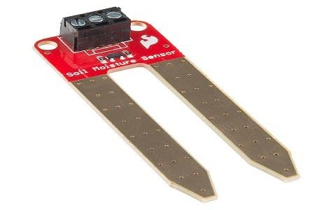
- Write working of soil moisture sensor and Blynk app.
This sensor mainly utilizes capacitance to gauge the water content of the soil (dielectric permittivity). The working of this sensor can be done by inserting this sensor into the earth and the status of the water content in the soil can be reported in the form of a percent. This sensor makes it perfect to execute experiments within science courses like environmental science, agricultural science, biology, soil science, botany, and horticulture.

Conclusion: After the study of this assignment we can use Blynk app and familiar with soil Moisture sensor.

